Repertory Dance Theatre - Jr. High Day of Dance
February 27 & 28, 2018

Participation Release Form
Rose Wagner Performing Arts Center

I, the undersigned, hereby represent that I am of legal age, or that I am the guardian of the student named below, and hereby release and forever discharge the Utah Dance Education Organization (UDEO), Repertory Dance Theatre (RDT), Salt Lake County and all members of said organizations and all agents, representatives and employees of said organizations and their successors from all claims and demands which I, my heirs, executors and administrators, have or may have against said organizations by reason of participation in classes, workshops or performances conducted by RDT, and hereby assume all risks in such activity.

________________________________________________
Print Student Name

_____________________________________________________
Signature of Parent or Guardian or Student if 18 or older

Address ______________________________________________

______________________________________________

_________________________________________
Emergency Phone Number

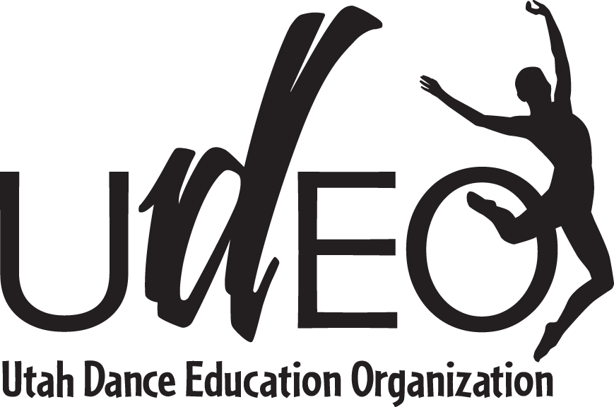

UDEO Student Photo Release
February 27 & 28, 2018

I hereby grant permission to the Utah Dance Education Organization (UDEO) to use, including publicly display, my student’s photograph as part of UDEO promotional videos, the UDEO website, or in other official UDEO publications without future notice. I acknowledge that UDEO has the right to crop, edit, or modify the photograph(s) at UDEO’s discretion.

I also understand that once my student’s photograph is published on a website, it can be downloaded by any computer user. Personal information, such as a student’s full name, parent’s names, address, and telephone numbers will never be published. If a student’s name is used with a photograph it will be in the form of a first name only. For example, student Jane Doe may be listed as “Jane.”

Therefore, I agree to indemnify, defend, and hold harmless UDEO, its officers, employees, agents, successors, assignees, and members (the “Indemnified Parties”) from and against any and all claims and liabilities resulting from this publishing.

Permission is granted for the use requested above.

Name of Student: __________________________________________

School Name: __________________________________________

Name of Parent/Guardian: __________________________________________

Signature of Parent/Guardian: __________________________________________

Date: __________________________________________

